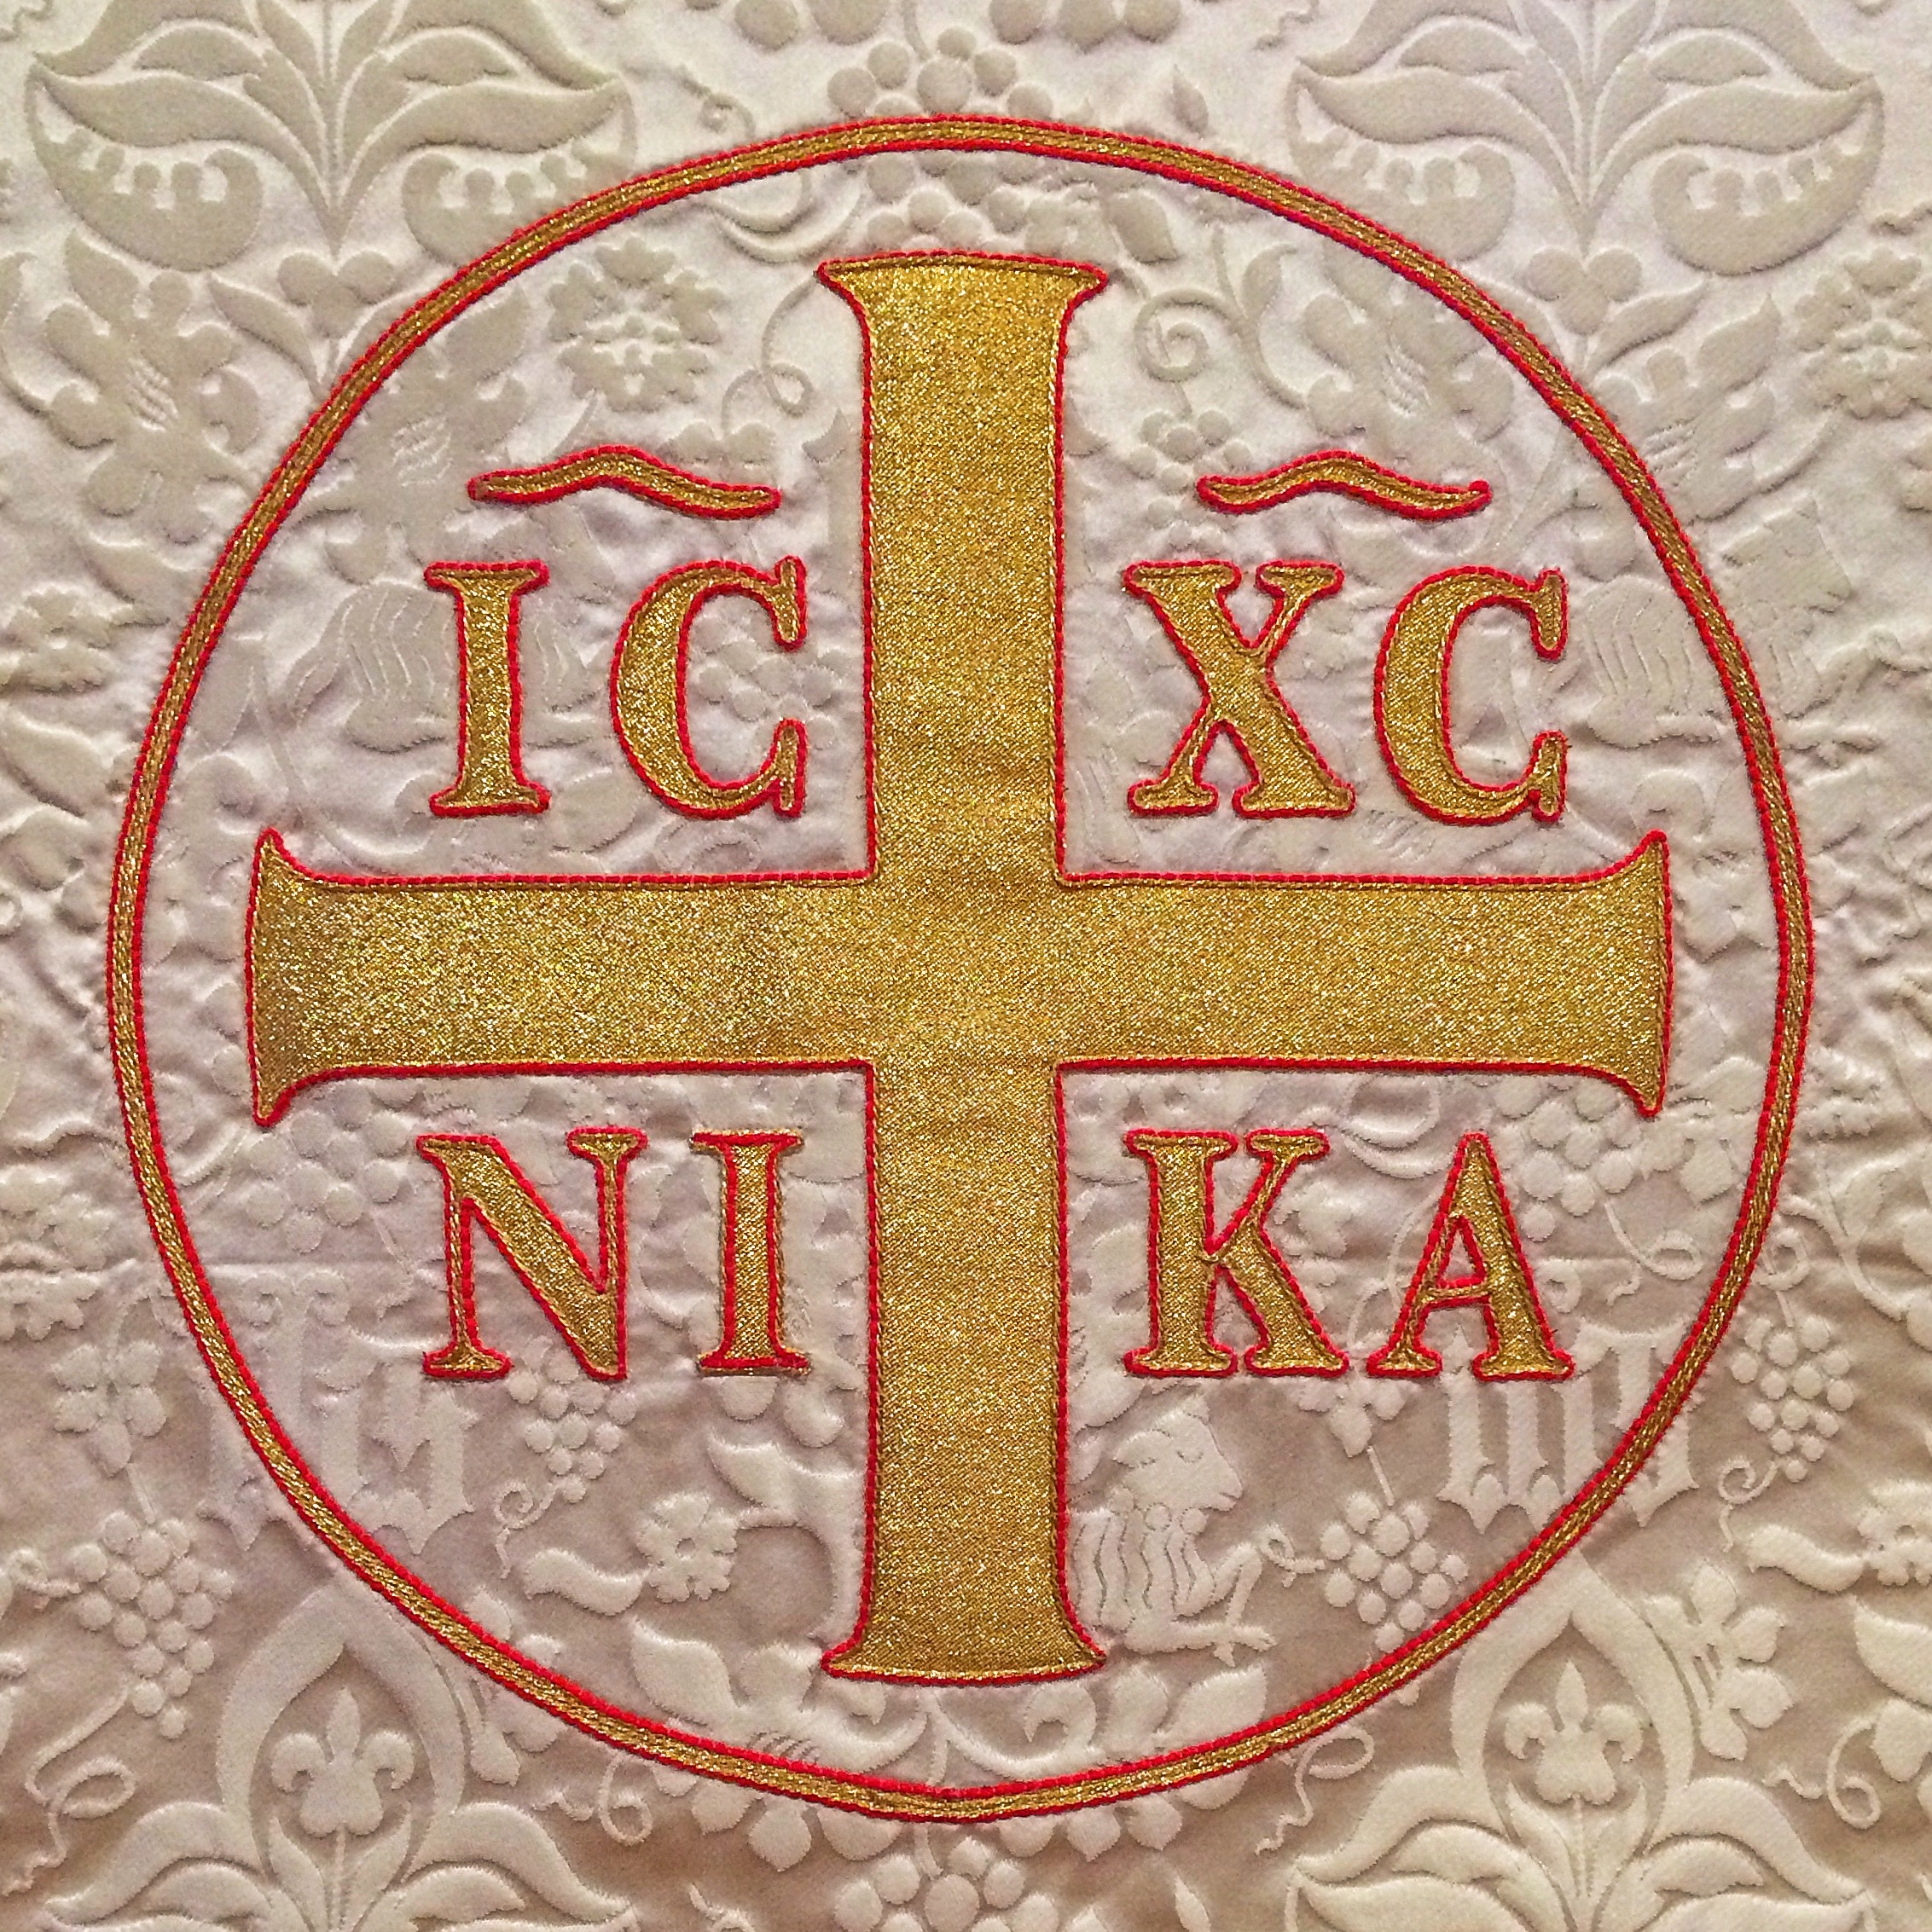
Trinity Evangelical Lutheran Church

1295 Middlefield Road

Palo Alto, California 94301

Telephone: (650) 853 – 1295

www.trinitylutheranpaloalto.com

A Congregation of

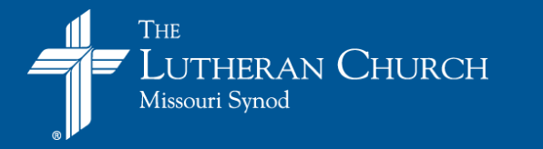
Weekly Schedule

Please refer to the website calendar and the weekly bulletin announcements for events.

Contents

Who We Are
We Believe
What We Are
What the Universal Church Is
What Our Congregation Is
What Our Congregation Does
Christ the High Priest
The Royal Priesthood
The Lay Priest
The Pastor Priest

Worship
- The Center of Our Life
- Daily Matins
- Confession & Absolution
- Worship Ceremonies
- The Sign of the Cross
- Bowing and Kneeling
- The Church Year

Christian Instruction
- Sunday School
- Catechumen Class
- Membership Classes for Adults

Obligations of Members
- Bearing Witness
- Loving One Another

Organization
- Ushers, Altar Guild, and Altar Attendants
- Societies
- Stanford University

Pastoral Visitations
- Special Supplications, Intercessions, and Prayers
- In Case of Sickness
- Private Communion
- In Case of Death
- Weddings

Questions and Problems

Speak Well of Your Church

Who We Are

We Believe:
- God is Triune, Father, Son and Holy Spirit, and that His being is a mystery.
- All people are sinners, separated from God, and cannot save themselves and deserve eternal separation from God.
- Jesus Christ, God’s Son and true man, was born, lived, suffered and died as the substitute for all people, bearing their sins, and that in Him God reconciled himself to the world; He was raised bodily from the dead as the testimony of God’s forgiveness of sin and as the promise of the Christian’s own bodily resurrection.
- Each person is saved from eternal separation from God only by the grace of God who gives faith in Jesus Christ by the Holy Spirit.
- Through the water and word of Holy Baptism, God adopts people as His children, setting them apart as His own and making them heirs of His eternal gifts.
- The Lord’s Supper is Christ’s true body and blood given to Christians to eat and drink for the forgiveness of sin and strengthening of life.
- In response to His love and mercy, Christians strive to live holy lives as the fruit of faith, and together with fellow Christians in the Church, will serve God and do His work.

This congregation holds to the Unaltered Augsburg Confession (UAC) of 1530. The Small Catechism provides another succinct summary of the confession of Trinity. The various booklets found in the church narthex explain the teaching of the Lutheran Church in greater detail. Fuller statements of belief are found at www.lcms.org/

What We Are
Trinity Evangelical Lutheran Church is a part of the Universal Church because the Word of God is taught in its truth and purity, the Sacraments are administered according to the institution of Christ, and we confess the Apostolic, Nicene, and Athanasian Creeds (Lutheran Service Book, inside back cover and page 319). This congregation is Lutheran because she accepts the historic Lutheran Confessions, the Book of Concord, as the true exposition of God’s Word: the Augsburg Confession, the Apology of the Augsburg Confession, the Smalcald Articles, the Small and Large Catechisms of Martin Luther, and the Formula of Concord.

What the Universal Church Is
The Bible makes the nature of the Church particularly clear in two pictures: That of the vine and its branches, and that of a body and its members.
Christ said, “I am the Vine, you are the branches: He who abides in Me, and I in him, he it is that bears much fruit: for apart from Me you can do nothing. If a man does not abide in Me, he is cast forth as a branch, and withers; and the branches are gathered, thrown into the fire and burned” (John 15:5,6). Here Christ describes the Church not as an organization, but as an organism, a plant, a grapevine. Christ calls Himself the Vine and the believers the branches. Taken together, the Vine and the branches are a living plant; this is a picture of the Church.
The other picture is that of a living human body of which Christ is the Head. “He (God the Father) has put all things under His (Christ) feet and has made Him the Head over all things for the Church, which is His body, the fullness of Him who fills all in all” (Ephesians 1:22,23). The members of the body are the believers; all true Christians, including both those who are still on earth, and those already in heaven. These believers are all united with Christ, Who is the Head of the body. Therefore, they are also members of one another. They are joined together in the bond of bodily membership, which is a bond closer than that of the members of an organization or even that of blood in a family relationship.
Both these pictures, then, convey to us the same message. Both the “vine” and the “body” are living organisms. Both are pictures of a hidden reality, the Church. Consequently, the Church is an organism and not just an organization. As an organism lives and has life in itself, so the Church is living and alive. The source of her life is Christ Himself. The branches of the Vine, the members of the body, can remain alive only by remaining united with Christ, the Vine or the Head of the body. The sap of a plant goes through the trunk of the plant into the branches, causing them to live, to grow, and to bring forth leaves, blossoms, and fruit. Likewise, the members of a body live and move and do their work as they are moved and directed by the head. If a branch or a member is separated from the rest of the organism, it withers and dies.

What Our Congregation Is
From what the Universal Church is, we can now understand what our congregation is. It is not just an organization like a “service club” or a “society for the promotion of ‘this or that.’” It is not just an institution or organization which “you join” for personal reasons and from which “you resign” or which “you quit" when you no longer wish to belong. This congregation is essentially the Universal Church in miniature in this place, this location. It is that which makes the Universal Church a concrete and tangible reality for us. The organizational aspect of the congregation is only an outwardly necessary thing for order, and other earthly requirements. This aspect is misunderstood and abused:
- If a person regards the congregation just as an organization which he can “join” or “quit” as he feels like it.
- If it is assumed that organizational methods and techniques will achieve the purpose of the Church.
- If the worldly success standards of an organization are applied to the congregation.
- If membership in the congregation, by itself and apart from faith, is equated with membership in the Body of Christ, the Church.

What Our Congregation Does
Our Lord gave to His disciples the command that they should preach the Gospel to every creature, baptize, and observe all things which He had instructed them to do. On the night in which He was betrayed, Christ instituted the chief worship service—the Holy Communion Service—of the New Testament Church, and commanded, “Do this in remembrance of Me.”
This, then, is what the members of Trinity celebrate. They preach the Gospel, administer the Word and Sacraments, and observe all of Christ’s instructions. Every Sunday they come together to carry out the Church’s worship. In our church the Holy Communion Service is celebrated every Sunday and on all major feasts. All members have the opportunity to partake of the Blessed Sacrament at every celebration and should do so frequently. When they gather together to “do this”, the Universal Church, the Body of Christ, comes to visible expression in this place. That is why the Holy Communion Service is the principal function of our congregation.
An altar is used to carry out the Church’s worship which Christ instituted. That is why the altar is the center of our worship. It symbolizes the presence of God and the sacrifice of Christ. Therefore, as you enter our church, the first thing that strikes you is the altar. Above it is a crucifix depicting the Incarnate (God made man) Christ on the instrument by which He redeemed us, the Holy Cross.
The Holy Communion Service is the chief service in the Church’s worship because it is the service which Christ Himself gave His Church “to do.” Other historic names for this service are the Holy Eucharist and the Divine Liturgy. The Holy Communion Service is carried out by “priests.” What kind of priests?

Christ the High Priest
The Church’s worship is carried out before the throne of God through Jesus Christ. He sacrificed Himself for us on the Cross. He redeemed us. He is our Savior. After His death He arose and ascended into Heaven. He is the Head of His Body, The Church, and the High Priest forever. As such, He does not sacrifice Himself again, nor is sacrificed, but He makes intercession for us and pleads His once-for-all sacrifice for us. In the Church’s worship, He is present and the benefits and blessings of His sacrifice are offered and conveyed to us by the Holy Spirit through the proclamation of the Word and the administration of the sacraments. By faith we are joined to Him and He brings our sacrifices with His own to our Heavenly Father.

The Royal Priesthood
The Holy Communion Service is carried out by the royal priesthood. This consists of true believers, men, women, and children, both lay people and clergy. Some Christians do not realize that they are priests. They think of a priest as a special minister who wears ornate vestments; but that is not the case in the Church worship. Here, all Christians are priests. They perform their priestly functions; but the Church’s worship is done together by two kinds of priests.

The Lay Priest
He is a baptized Christian. If he was baptized in infancy, he should also have been confirmed. His duty is to be present when the Holy Communion Service is carried out. For he belongs to the royal priesthood by which the Holy Communion Service is done.
He must also participate intelligently. Therefore, he must study the Bible, the teachings of the Church, and the orders of services in the Lutheran Service Book. He should also prepare himself before the Holy Communion Service by reading the Introit, the Collect, the Epistle, the Gradual, Alleluia Verse or Tract, and the Gospel.
One part of the lay priests’ duties is the offering of sacrifice. This consists of sacrifices of self, prayer, praise, and thanksgiving. We express this offering also in the material gift of money; the money is a token. A token is something that stands for something else. The token of money stands for ourselves. By it and in it we are carried to and placed on the altar of God. It must not merely be a donation, but a token of ourselves. This identification of ourselves is not done automatically. It requires a sacrificial act of the will, of self-giving. When the money is placed on the altar, we should say: “In these material things, O Lord, I offer You myself, wholly, unconditionally, with all that I am and have.”
The Pastor Priest
Christ has given the office of the Holy Ministry as an important gift to His Church. Pastors have special functions to perform in the worship and life of the Church. They have things to do in addition to the duties of lay priests. According to the Word of God, they are to carry out the “public” administration of the Office of the Keys, which includes the administration of the Word and the sacraments. They are to be the “overseers of the flock” or the congregation. They are to be the fathers-in-God of their congregational families. For the sake of their office, they wear clerical vestments. In the Book of Concord, the Lutheran Church has retained the traditional vestments of the Western Christian Church.

Worship

The Center of Life
The Christian congregation exists for the principal function of celebrating the Holy Communion Service. This is the center of the congregation’s life. When Christians meet together in the Presence of the Risen Lord, they are the Church, the Body of Christ localized. That is why we call the Holy Communion Service the life of the congregation; yet the Holy Communion Service does not come to an end after the service. It extends itself in many other activities of the congregation.

Weekday Matins
The Holy Communion Service extends itself in such minor services as the Preaching Service, and the daily offices of Matins and Vespers. These preaching and prayer services revolve around the Holy Communion Service as the planets around the sun. In them the Church’s worship is extended from Sundays through the following weekdays. In our church Matins are conducted Tuesday through Friday at 9:00 a.m. All members who can attend these are urged to come. Vespers are held as announced in our church bulletin.

Confession and Absolution
Christ gave to His Church the power to forgive and retain sins. This power is exercised officially by the pastors. The Lutheran Church has retained Private Confession and Absolution, not as something obligatory, but as a great privilege and blessing in the Church, primarily on account of the absolution. Private Confession and Absolution is practiced by appointment with the pastor. It is carried out in the church building at the communicants’ rail. We there follow the order prescribed by Martin Luther in his Small Catechism. We encourage our members to avail themselves of the blessings of Private Confession and Absolution.

Worship Ceremonies
Ceremonies are needful for order and reverence in worship, and assist us in our devotion. They are also an outward expression of our reverence to God and holy things, as well as a sign of our unity with the Church in past ages. In line with the historic Lutheran Confessions, we at Trinity teach the use of the traditional ceremonies that we believe to be an asset to Christian worship and useful in training for devotion. We do not, however, make any laws about ceremonies but keep them strictly in the area of Christian liberty. Therefore no one is to criticize or condemn anyone for any ceremony that may be used unless it is contrary to the Holy Scriptures.

The Sign of the Cross
One ceremony, which has come down to us from apostolic days, is blessing oneself with the sign of the Cross. This is not “catholic” in the sense of Roman Catholic, but was recommended by Martin Luther.

Bowing and Kneeling
According to the Bible, the people of God have always used the ceremonies of bowing and kneeling in worship. We recall the words, “O come let us worship and bow down; let us kneel before the Lord our Maker,” (Psalm 95:6) and “At the Name of Jesus every knee shall bow” (Philippians 2: 10). We therefore encourage kneeling for confession and bowing at the Holy Name of Jesus, etc.

The Church Year
To help us live in and with Christ and the Church, we observe the traditional Church Year with its seasons and feasts in our church worship. We also recommend to our members to observe the Church Year in their personal and family life with Christian customs and ceremonies. Such a practice is particularly important for the training of children. Consult your Pastor about suitable prayer books for private and family devotions, as well as for literature on Church Year observances.

Music
Trinity’s adult choir welcomes those of high school age and older; a children’s choir trains the younger voices of the congregation. Their purpose is to lead the congregation in meaningful worship and to perform sacred music that glorifies God as an integral part of worship. Members of the choir may also serve as cantor. And if you are musically inclined, the music director is always looking for additional voices.
Christian Instruction

The aim of Christian education in Trinity is never just to teach a “subject”, but a living faith. This faith centers in Christ and our life in the Body of Christ, the Church. Since this life has its source and growth in Baptism and the Holy Communion Service, we never look upon Christian education as something separated from the Church’s worship. Rather, all our education aims at participation in the church services, primarily the Holy Communion Service. The Christian education and training of children is the duty of parents.
Topics vary from contemporary issues to biblical books to doctrinal studies. Books of the Bible are studied as well as various topics pertinent to our Christian faith. At various times there are adult instruction/review courses for those desiring to review the faith.
Sunday school classes meet every Sunday from 10:30 to 11:30. There are classes for children who are 2 (with parent) through grade 12. Our dedicated teachers and helpers strive to provide Christian instruction through Bible stories and how they apply to the children's everyday life.
During the last week of July / first week of August the congregation hosts a vacation Bible school

Sunday School
Classes are conducted for the people of God, whatever their ages. Sunday school is held for the children, and Bible classes are offered for young people and adults. The Sunday school is not worship, but instruction and edification in the Christian faith. With our arrangement, everyone has the opportunity to attend both Sunday school and church every Sunday.

Catechumen Classes
Catechism classes are conducted on Sundays and according to the schedules of the families; the sessions run concurrently with the school year. The first year of catechism, 6th grade, studies the chief teachings of the Church, as summarized in Dr. Luther’s Small Catechism; at the conclusion of the year, the catechumen is examined to determine if he or she is able to prepare oneself for the Holy Communion. The 2nd year takes the catechumen through an overview of the Old Testament & the Catechism and the 3rd year studies the New Testament & reviews the Small Catechism. Upon completion of catechesis, which concludes with a pastor-catechumen examination and an essay, the catechumen is deemed ready for the rite of Confirmation. However, confirmation is in no sense a “graduation from school.” It is the beginning of a greater expression of membership with all its duties, privileges, and blessings. Among these duties is the continuation of Christian education.

Membership Classes for Adults
In these classes, the teachings and the worship of the Church are discussed. By attending them, adults are given the opportunity to become understanding members of the Lutheran Church. The classes also serve as a “refresher” course for those who were confirmed in the Lutheran Church as children.

Weekday Bible Classes for Adults
On Tuesdays at 4:00 p.m. and Wednesdays at 10:00 a.m. adult Bible classes are taught. We also provide resources for home Bible studies. Our library subscribes to The Lutheran Witness (an excellent resource with its engaging articles) and other inspirational and informative periodicals; the library also has a wide variety of books for growth in faith and knowledge of the Scriptures.
Obligations of Members

We expect that every member of Trinity is present, if he is able, for the Church’s worship every Sunday. It is also expected that members serve Christ with their time, talents, and money, “as God has prospered him.” Failure to do these things is a sin because it is a transgression of the law of God, and therefore makes a person subject to church discipline. Church discipline, however, must always be exercised in love, not with the object of punishing anyone, but to save him.

Bearing Witness
Christ commanded His disciples to bear witness to Him. Every member of our church should, therefore, do mission work, speaking the good news to all who do not attend a church. Collectively as a congregation, we are to bring the Gospel to all the world by supporting with prayer and money the work of our Synod at home and abroad. This congregation participates in a variety of mission societies, those sponsored and organized locally, as well as those overseen by the church’s larger structures.

Loving One Another
Christ commanded: “Love one another even as I have loved you.” Therefore, every member will seek to express his love by visiting the other members with concern for their spiritual and physical welfare, especially the delinquents who fail to come to church regularly, the sick, the afflicted, the troubled, and the tempted. We are members one of another. We are committed to reaching out in Christ’s love to the people of our area and our world. We donate food, funds and other supplies and services to the Ecumenical Hunger Program and to LifeMoves.

Organization

Our Constitution and By-Laws specify all organizational matters. Please get a copy from the church office and use it for reference.

Ushers, Altar Guild, and Altar Attendants
To carry out needed functions in the worship services of the church, we ask all who are able to serve as ushers, choir members, altar guild workers and altar boys, to volunteer their help. Please do not wait to be asked, but rather ask if you may help in one of these ways.

Societies
Societies within our congregation provide opportunities for Christian service and fellowship. To exercise love, we must first of all get acquainted. Now members especially, therefore, are urged to come to society meetings where they can learn to know their fellow-members better. You really cannot learn to know people through church attendance. Ask the Pastor about the time when these societies meet.

Women’s Guild (LWML)
The members support various activities and the Mite Projects of the Lutheran Women’s Missionary league (LWML). All women in the congregation are cordially invited to participate, for through participation in the Guild the women of the congregation mature in fellowship of the Body of Christ and exercise the talents that the Lord of the Church has given.
LCMS U
The Lutheran Church-Missouri Synod is represented on the Stanford University campus by Trinity congregation. LCMS U is a group of college students and college-age adults based at Trinity Lutheran Church in Palo Alto. This group, guided by Scripture and prayer, aims to reach out and to serve the Stanford University community by providing a Scripture- and Sacrament-based witness through:
- Opportunities for worship
- Fellowship
- Social interactions and friendship
- Encouraging individuals in their faith
- Equipping individuals to be witnesses
- Opportunities for outreach and service
This ministry, anchored in God’s Word and prayer, seeks that which God offers and gives–the forgiveness of sins earned by Christ. It is here that all people find true life.

Pastoral Visitations

The purpose of these visitations is not primarily “to get money” or pledges, but to express our loving concern for one another as members of the Body of Christ. We must help, encourage, and admonish one another to participate in the church services faithfully and to be active in the other functions of the congregation. God gives us our time, talents, and money for use in His work, the work of the Church. “Blessed is that servant, whom his Master when he cometh shall find so doing” (Matthew 24:46).

Special Supplications, Intercessions, and Prayers
When a member is seriously ill, when death occurs in a family, when God blesses parents with the birth of a child, when a member is in grave danger, when God has given a member a special blessing, then ask the pastor to include these things in “The General Prayer” of our Sunday services. He cannot do this without a request. Therefore, make your desire known to him, so that the whole church can pray with you and for you.

In Case of Sickness
“Is any among you sick, let him call for the elders (pastors) of the church, and let them pray over him, anointing him with oil in the name of the Lord; and the prayer of faith will save the sick man, and the Lord will raise him up; and if he has committed sins, he will he forgiven” (James 5:14,15).
Private Communion
For those who are physically unable to come to the Holy Communion Service, our church provides for the extension of the Blessed Sacrament to them by the pastor. Such members must be spiritually participants in the congregation’s celebration of the Holy Communion Service and must think of this and pray over it when the service is held in church. Holy Communion is always what it is called, a “communion”, a sacramental fellowship with Christ and all believers as members of the Body of Christ. It is for this reason also, that we retain the chalice, the common cup, in the Holy Communion Service.

In Case of Death
The pastor should be notified immediately when a member has died and should be consulted about plans for the funeral service before any arrangements are made. For members in good standing, the funeral service should be held in church. A booklet, Alive in Christ, is available from the church office; it provides an overview of the Christian funeral and has a section for individuals to prepare for a funeral service.

Weddings
The pastor should be consulted about wedding plans before any arrangements are made. A wedding in church is a church service, as divine and reverent as any other church service. All music, decorations, and ceremonies are under the jurisdiction of the Pastor. A booklet for couples considering marriage is available from the pastor.
Questions and Problems

If anyone has questions or difficulties about the church, its activities, its beliefs, customs, ceremonies, and practices, he should talk to the Pastor and get his information from him directly. Misinformation and misunderstanding can be avoided that way. Take your pastor into your confidence. He can help you.

Speak Well of Your Church

Our members should convey the joy of being a member of this congregation to others. Let people know that you believe in the things that your church teaches and does. Talk about Christ and how the benefits and blessings of His redemptive work are offered and conveyed through the administration of the pure Word and Sacrament every Sunday. Talk about the beauty and deep spirituality of the church services. Talk about how we relive Christ’s life with Him in the feasts and seasons of the Church Year; how we continue the prayers and the Gospel of the Holy Communion Service through the week in daily Matins; how the church is always open; how you are given the opportunity for Private Confession and Absolution according to Christian custom as explained in Luther’s Catechism. Let us, therefore, be thankful for the blessings we have in Trinity Evangelical Lutheran Church of Palo Alto and tell others about them.

