A Guide for the Divine Service

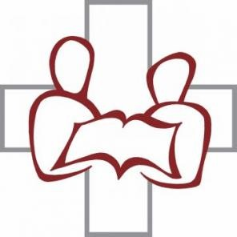

Trinity Evangelical Lutheran Church
Palo Alto, California

Acknowledgments

This narrative is an adaptation of “A Narrative Commentary on the Divine Service” written by the Rev. John T. Pless and included in his Didache. Used by permission. (revised Trinity 2, 2018)

Introduction

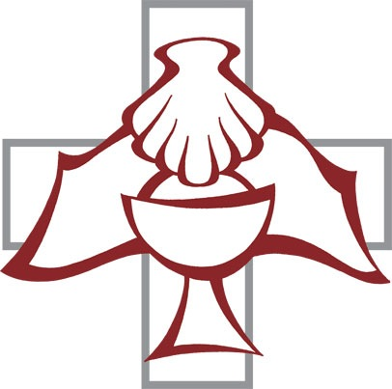
The high and holy worship of God is faith in Jesus Christ. Such faith is created and sustained by God drawing near to us. Because God comes to serve us with His Word and Sacraments, the service is a divine service and not a human service. In this Divine Service, the Lord comes to us in order to bless and enliven us with His gifts. Therefore this service is not chiefly something that we do for God, but this time and place and means—set aside to receive His gifts—are His service to us to be received in faith.
That is the heart of Lutheran worship. Since the Lord's Ascension into Heaven, His followers have met to hear His Word and celebrate the Holy Baptism and His Holy Supper, which He instituted under the leadership of His appointed Apostles.
The liturgy, because it draws our faith to behold the works of God in Christ, is God’s work. We cease our labors when we are gathered for the Divine Service so that He might work in us. He gives; we receive.

The Divine Service expresses the right relationship between God and man. This right relationship is a gift of grace, which Christ, in His own flesh and blood, has won for us on the cross. The Divine Service, therefore, is not fulfilling external rites and ceremonies, as if mere forms constituted good worship; neither is the Divine Service arbitrary in practices.
In the Divine Service, individuals together acknowledge Christ as Lord and receive His means of grace, Word and Sacrament; and their worship is based on the historic liturgies of the ancient church. Why? Because these are biblical, meaning both the Divine Service expresses biblical truths and in many cases the liturgy employs biblical passages that are “put into the mouths of worshippers” so that God Himself may teach them how to pray.
In the Divine Service, people leave the things of the world, which pass away, to enter into the Presence of God, Who is eternal, and to receive His gifts that neither spoil nor perish. They hear His Word, which is eternal. They remember the enduring promise of Baptism – having died with Christ, they shall live with Christ (Romans 6:1-14); they receive the Body and Blood of Jesus Christ, which affirms the new and everlasting covenant – Jesus is the one Mediator between God and man.
Many of the practices of Christian worship are intended to remind us that we are citizens not of this earth but of Heaven, and are therefore strange to those who are uninitiated or feel more at home in the world.

This commentary on the Divine Service will introduce you to the service and the meaning of the service as it is practiced among some Lutherans. However, since it is an introduction, it will not answer all questions that you might have. A brief glossary, at the end of the booklet, defines some terms not described in the commentary.
In this booklet each part of the Divine Service, as used in Lutheran Service Book (Concordia Publishing House, 2006), is prefaced with a commentary, including Bible passages on which the portion of the service is based. The commentary (on the left hand pages) explains the structure and biblical content of the Divine Service (on the right hand pages) in order that the Church might more fully rejoice in the gifts that the Lord Jesus Christ Savior gives His Church in His liturgy (John 4:20-26; Hebrews 8:1-6).

The Main Divine Service

Within the Lutheran tradition of congregational worship a distinction has been maintained between Hauptgottesdienst, the “Main Divine Service,” which is a celebration of Holy Communion, and Nebengottesdienste, the “Minor Services,” which included "Matins" (Morning Prayer), "Vespers" (Evening Prayer), and a variety of preaching, confessional, and catechism services. In the Main Divine Service the components that remain the same are called the “Ordinaries;” the components that may change from week to week or seasonally within the calendar of the Church Year are called the “Propers.” The “Propers” include: Introit, Collect, Lessons, Gradual, Hymns, Sermon, Offertory, and Proper Preface. The combination of the Ordinaries and the Propers within the service provides for both continuity and variety.

The Prelude
Preservice music helps to establish an atmosphere for worship. It focuses our attention and draws us into an attitude of prayer and praise. The organist’s carefully chosen Prelude indicates the tone of the day’s service and prepares the congregation for what will follow. The world’s most beautiful music has been written and performed by devout Christians as an expression of their adoration and love for the Lord Jesus. Luther expressed his high regard for music when he said, “I would gladly see all arts, especially music, in the service of Him who has given and created them.”

The Preparation

Hymn of Invocation
The Lutheran Church has often been described as the “Singing Church” because of our emphasis on the importance of congregational participation in the worship service. St. Paul urges: “Let the Word of Christ dwell in you richly as you teach and admonish one another with all wisdom, and as you sing psalms, hymns, and spiritual songs with gratitude in your hearts to God” (Colossians 3:16). The Hymn of Invocation continues the theme established in the Prelude.

Invocation
From God’s Word, we know that wherever God puts His Name, there He is to bless. In the Old Testament, the Temple was the place where God graciously caused His Name to be present (I Kings 8:27-30). God has put His Name – Father, Son, and Holy Spirit – on us in Holy Baptism. Thus, the Divine Service begins, “In the name of the Father and of the Son and of the Holy Spirit,” calling upon (invoking) God’s name and reminding us that this is His Service to us. During the Invocation, you may call to mind your baptism by making the sign of the cross, for baptism is where we first received the sign of the cross.
Every Divine Service is for the hallowing of the Lord’s Name, which the Small Catechism reminds us is done “When the Word of God is taught in its truth and purity and we as the children of God, also lead a holy life according to it” (Matthew 28:18-20; John 16:23; 1 Corinthians 12:3; Ephesians 2:18; Colossians 1:9, 2:9, 3:17).

Confession & Absolution
Only through the forgiveness of sins may we enter into the life of Our Father. To confess our sins is to speak the truth about our lives. He seeks that truth in the heart and on the lips. To confess our sin is to say “Amen” to God’s just verdict that we have sinned against Him and so deserve only eternal separation, death and hell (1 John 1:8-10; Hebrews 10:22-25; Psalm 32:5, 124:8).

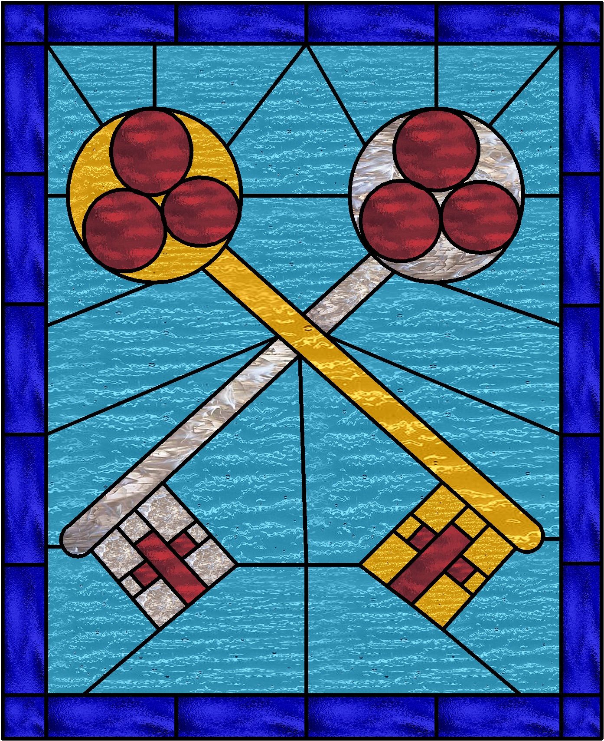
The truth of our sinfulness is answered by the truth of God’s forgiveness for the sake of the suffering and death of His Son. From the lips of a man “called and ordained” (as one called by God and ordained through the Church) as a servant of the Word, we hear God Himself speaking absolution, that is, the forgiveness of sins. To that forgiveness faith says, “Amen,” that is “Truth.” “Amen” is the great word of worship; it indicates that the gift has been received (John 20:19-23; Romans 7:14-8:4).

The Service of the Word

This portion of the service listens to the Risen Christ as He teaches us with His word. This portion of the service holds to traditions of the ancient church’s worship, which is centered on the reading of the Scriptures. The public reading of the Scriptures and proclamation of the Word is at the heart of our service (1 Timothy 4:13). The foundation of our faith is that the Word of God alone raises us up to be the children of God.

Introit
In ancient times the entire congregation entered the building in a solemn procession, singing psalms and songs. So also we enter upon the main part of the Divine Service with the Introit, or entrance song. The Introit, which means “he enters,” is made up of the Lord’s own words, most often drawn from the Psalms; introits set the tone and give the theme for the various Sundays and festivals of the Church Year. Having received the Lord’s forgiveness, we are glad to enter His courts with praise and thanksgiving (Psalm 100).

Gloria Patri
With the Gloria Patri (Latin for “Glory to the Father”), we offer praise and thanksgiving by giving glory to the Triune God who has called us there (Romans 16:27; Ephesians 3:21; Philippians 4:20; Revelation 1:6).

Kyrie
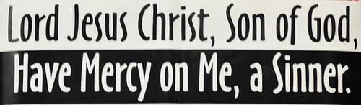
Kyrie eleison is a Greek phrase that means “Lord, have mercy.” In the Kyrie we come before the King of Mercy with the prayer that was on the lips of blind Bartimaeus, whom Jesus healed. We, as citizens of Heaven, approach our Merciful Savior and King, seeking His mercy for our salvation, the peace of the whole world, the well-being of His Church, our worship, and our everlasting defense (Mark 10:47-48; Matthew 9:27, 15:22, 17:15, 20:30-31; Luke 16:24, 17:13, 18:38).

Gloria in Excelsis
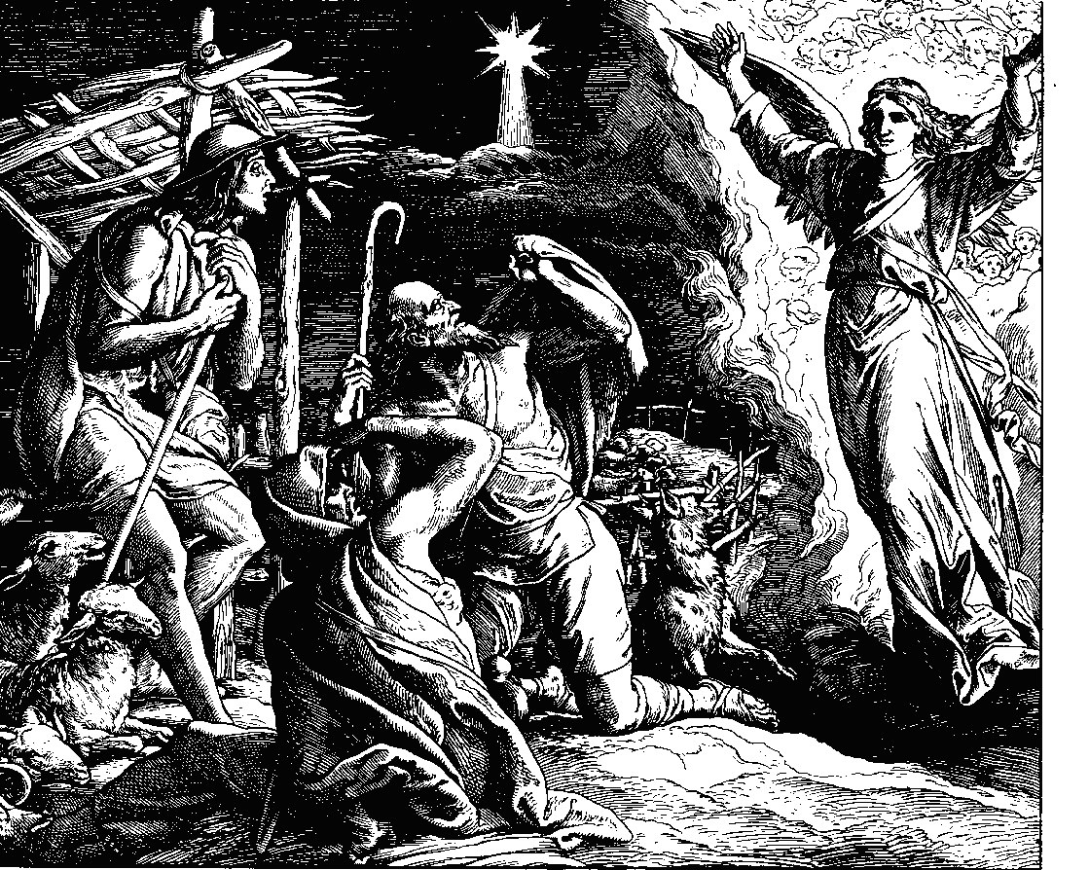
The Lord to whom we cry for mercy is the Savior who has come to us in the flesh. Therefore we lift our voices in the Gloria in Excelsis, which means “Glory be to God on High;” this cry greets the Lord who has come even before we begin to cry for help. In doing so, we join the high angels of God who sang to the shepherds at Bethlehem. In this hymn we acclaim and extol the Son of God who humbled Himself to be our Brother and now reigns over us as Savior from the right hand of His Father (Luke 2:14).

Salutation
The pastor stands before the congregation as Christ’s servant. The vestments he wears indicate that he is not speaking on his own, but as one sent and authorized to represent Christ Jesus. As the authorized representative of the Lord he says, “The Lord be with you.” The congregation responds, “And with your spirit.” Pastor and congregation are bound together in this salutation, or greeting, as the pastor prays the Collect of the Day on behalf of the gathered congregation (II Timothy 4:22; Luke 1:28; Judges 6:12; Ruth 2:4; II Thessalonians 3:16; Galatians 6:18).

Collect
The Collect is a brief but significant prayer which expresses the theme of the day. Collect is derived from the Latin title of services where Christians gathered together for prayer (ecclesia collecta). A complete collect traditionally contains five parts: a basis for the petition, the petition, the purpose or benefit desired, a closing doxology (song of praise). With an unbroken use of nearly fifteen centuries by multitudes of believers in all lands, the collects constitute an important part of the liturgical inheritance of the Church. We prize them for their antiquity, universality, excellence, and beauty (Philippians 4:6; Ecclesiastes 5:1-3).

The Readings
In Ephesians 4, the Apostle Paul tells us that the Ascended Christ gave gifts to His Church: Apostles, Prophets, Evangelists, and Pastor-Teachers. These gifts are made manifest in the Divine Service as we hear God’s Word read and proclaimed.
A lectionary, a series of readings consisting of pericopes (from the Greek “to cut around”), help to insure that the Divine Service is not subject to the whims or interests of an individual pastor or the local concerns of a congregation.
First, we hear from a Prophet in the words of the Old Testament Reading; however, in the weeks after Easter, the first reading comes from the Book of Acts instead of the Old Testament. After the pastor reads the Scripture he proclaims “This is the Word of the Lord.” The Lord’s Word is embraced by the congregation’s response of thanksgiving: “Thanks be to God.” In this way the Church confesses Holy Scripture for what it is—the Holy Word of God (Ephesians 4:11).
The Gradual, selected verses of Scripture, is then either said or sung by the congregation. This response is a “bridge of praise” that links the Old Testament reading to the next reading (Colossians 3:16).
Second, we hear from an Apostle in the words of a New Testament Epistle. From the Apostle we are given the truth in Jesus for our faith and our daily lives.
Having heard the Epistle the congregation stands and sings Alleluia, the song of the angels. In singing the Triple Alleluia, we thank and praise the Holy Trinity - Father, Son and Holy Spirit (John 6:63; Revelation 19:1-6; Psalms 113-118).
Third, we hear from an Evangelist (Matthew, Mark, Luke, and John) in the words of the Holy Gospel. In the words of the Evangelist we are given the Word of Life, Jesus Christ. The congregation acknowledges the Lord’s presence in His Gospel by standing and extolling His glory and praising Him.

The Creed
Having heard the Word of God, we confess our faith in His Name. The Creed is our “saying back” to God what He has first said to us. In the Nicene Creed we acclaim the truth of the Triune God and His work of salvation accomplished for us in His Incarnate Son, Jesus Christ. Since the Creed is a summary of the faith, in confessing it we are saying “Amen” to the main content of the entire Gospel (Matthew 10:32-33, 16:13-17; Romans 10:9-10; Philippians 2:5-11; Jude 3; Deuteronomy 6:4; Acts 2:42).
The Creed is a confession of our holy Christian faith, based upon the Word of God; a confession is a faithful and logical consequence to the reading of the Holy Scriptures. Every use of the Creed is a confession of God’s baptismal covenant, affirming His life-giving word. The comprehensive wording of the Nicene Creed (adopted at the Ecumenical Council of Nicea, AD 425) “witnesses to the perpetuity, unity, and universality of the Christian faith; it binds Christians to one another and to the faithful of all centuries” (Luther Reed, The Lutheran Liturgy).

The Hymn of the Day / Sermon Hymn
Following the Creed, our praise continues with our sung confession of the faith. As the Word of God dwells in us it calls forth songs of faith and love. This chief hymn of the Divine Service reflects the particular theme of the Scripture readings (Colossians 3:16).

The Sermon
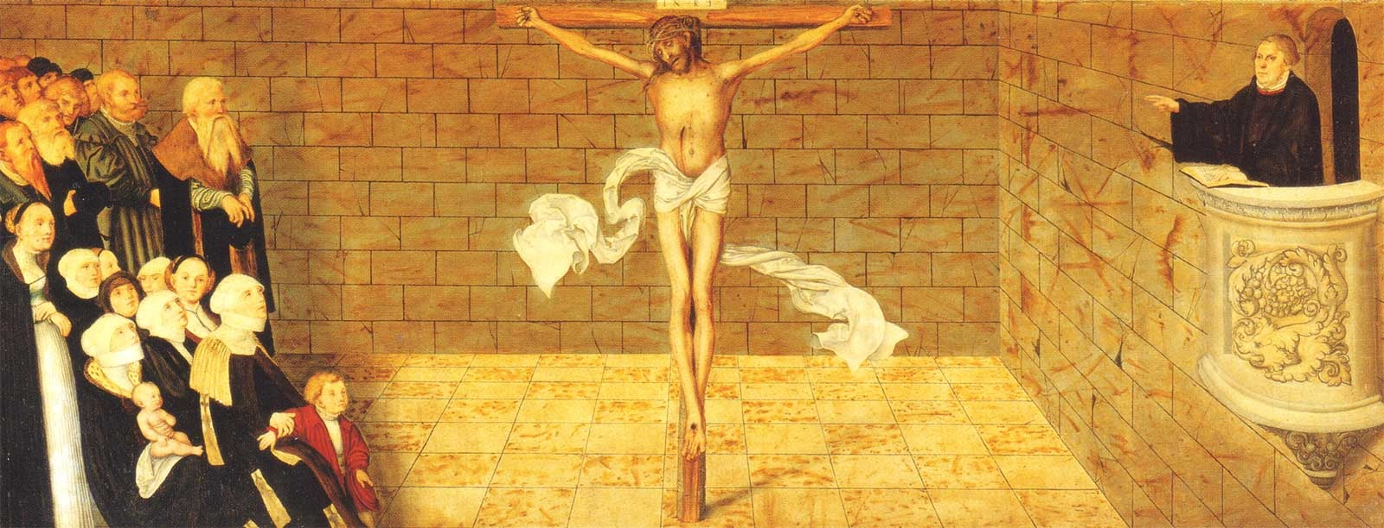
In continuity with Our Lord’s Prophets, Apostles, and Evangelists, which were sent to preach the forgiveness of sins, the promise of eternal life, and our salvation found in Christ Jesus, the pastor stands in our midst to deliver the Lord’s Law and Gospel in the sermon, thoroughly explaining and applying the Scripture just heard. The pastor is God’s mouth for the congregation as through him the Chief Shepherd’s voice sounds forth to call, gather, and enlighten His flock (Luke 10:16).

Offertory
Having heard both Law and Gospel expounded and proclaimed in the sermon, the congregation rises and joins in the song of David after he was restored by the prophet Nathan. Since we ourselves have been restored through the Gospel, his song becomes our own (Psalm 51:10-12).

Offering
Likewise, having received from the generosity of the Father, who is the Author and Giver of every good and perfect gift, we now give of the gifts that He has given to us. Following the pattern of the apostolic church in 2 Corinthians 8-9, the congregation collects gifts to support the proclamation of the Gospel and works of mercy among those in need. The offering represents the worship of Christian lives offered in response to God, and unites us in an act of fellowship (2 Corinthians 8-9; Romans 12:1).

The Prayer of the Church
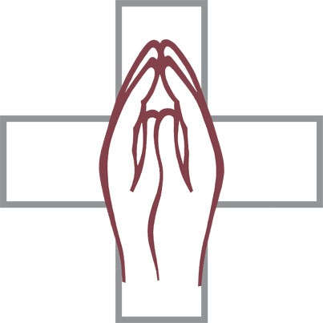
God’s Word is always primary in worship. We speak only as we are spoken to. Gathered in Jesus’ Name, we bring the petitions and thanksgivings before Him that grow out of His Word. This prayer is called the Prayer of the Church, for in it the Royal Priesthood of All Believers does its priestly work of making “supplications, prayers, intercessions, and thanksgivings for all men, for kings and for all who are in high positions, that we may lead a quiet and peaceable life, godly and respectful in every way” (1 Timothy 2:1,2). This prayer may include prayers for the local congregation, the church at large, for right teaching, protection from the devil, the government, the military, all who suffer, the welfare and safety of ourselves and others, for the conversion of the unbeliever and the restoration of those who have left the Church.

The Service of Holy Communion

This Service is the celebration of the Lord’s Supper, which was instituted by Christ for the forgiveness of sins (Matthew 26:26ff.). During the Lord’s Supper, we partake of Christ’s sacrifice and atonement in His true body and blood. Through this we are made one with Him and all Christians throughout the world and all the saints who have gone before. This is why we call it Holy Communion.
This is the fulfillment of the ancient temple worship in the Old Testament. Blood of animals was shed in the past to cover the sins of the people. Now, Jesus’ blood was shed on Calvary and Christ gives us this to eat and drink by the fruits of the cross, the Savior’s body and blood under bread and wine.
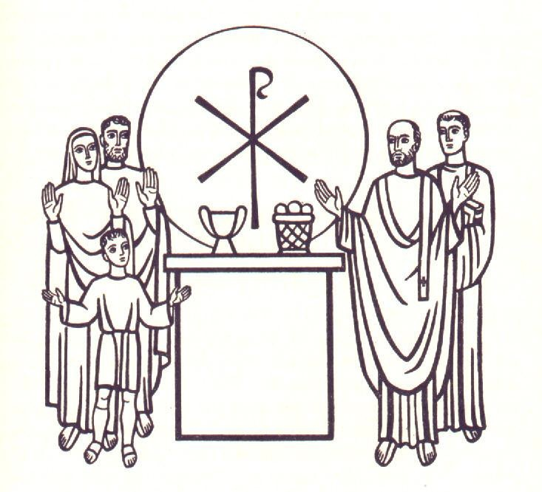
At this point in the ancient church catechumens (those who were preparing for Baptism and Communion) and all visitors were dismissed (the word “Mass” comes from this dismissal). Only those who had been instructed in Christian teaching were to remain to witness the celebration of Holy Communion and to receive Christ’s Holy Body and Blood in the Sacrament. This is “closed communion” as originally practiced; communion is closed to all except those who have been taught the faith and confess what the Lord gives to His people in the Holy Supper. It is now our custom to allow and even encourage those who are not receiving communion to witness this portion of the service, but only those who have been instructed in the Christian faith and examined by the pastors presiding receive Holy Communion. Like a powerful medicine it is to be taken by those whose malady has been diagnosed and explained to them.

Preface
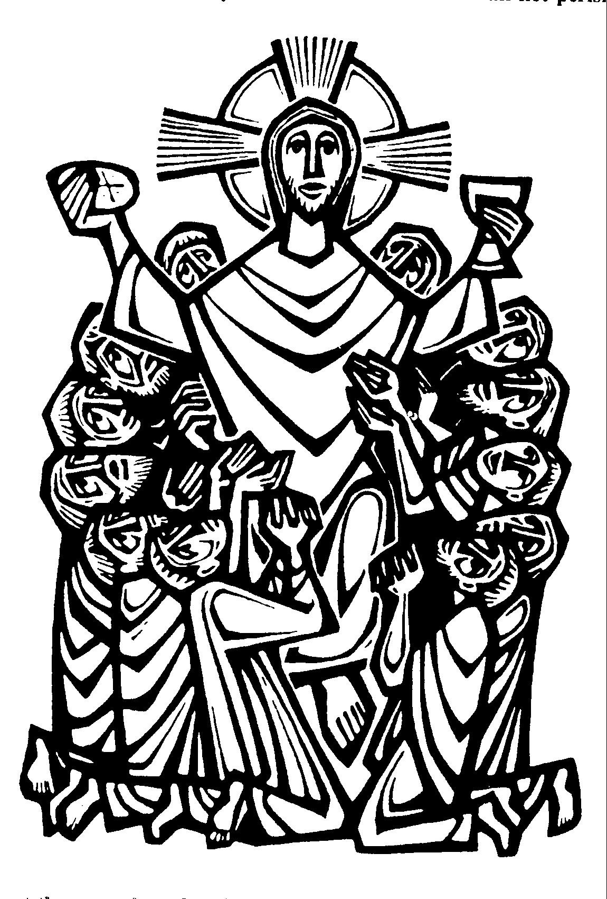
Drawn toward the gifts of Jesus’ Body and Blood, our hearts are lifted up in thanksgiving and praise as we anticipate the reception of the gifts that carry with them our redemption. The Preface is a dialogue between the presiding minister and the people. He calls on them to give thanks (in Greek eucharist) as they recall Christ's work of Salvation and anticipate receiving of the benefits there from in Holy Communion. The Preface begins with the Salutation, which indicates the significance of that which follows and emphasizes the unity of the Holy Supper as we share in the Body and Blood of our Lord.
The celebration of the Holy Supper is indeed a eucharist (I Corinthians 10:16), a thanksgiving for the divine gifts of grace which flow to us from the sacrificial life and death of our Lord Jesus Christ.
A seasonal theme, called the Proper Preface, is chanted or spoken at this point, and it recalls specific acts of redemption appropriate for that time in the Church Year as the special occasion for thanksgiving.
The Preface concludes with a triumphant invitation to the Church on earth to unite in praise with “angels and archangels, and with all the company of heaven.” “The church's worship on earth tends toward a point where it may unite in an eternal unison with the worship of the celestial hosts . . . Because they have the same center, the Lamb that was slain, they stand in real communication with one another. The church on earth may already join in the praises of the angels and pray God to grant that its voice on earth may unite with the Sanctus of the angels in heaven.” (Peter Brunner, Worship in the Name of Jesus).

Sanctus
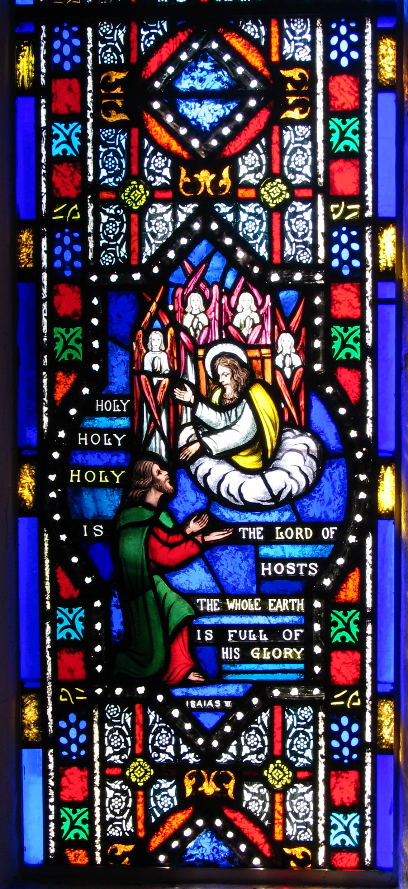
“The Sanctus, which derives its name from the Latin word for `holy,’ is the climax and conclusion of the Preface. It is a solemn act of adoration and thanksgiving in the spirit of holy awe. It has been called `the most ancient, the most celebrated, and the most universal of Christian hymns’” (Luther Reed, The Lutheran Liturgy).
The Sanctus opens with the seraphim’s dramatic acclamation of the divine majesty from Isaiah 6:2,3. The ringing trisagian (Greek for “three holies”) expresses the awe and wonder of the creature in the glorious presence of the Holy One of Israel. In that vision of Isaiah the prophet God revealed Himself as Yahweh Sabaoth, a title that emphasizes His almighty power and commander of the angelic hosts. The majestic opening phrases of the Sanctus set the stage as we prepare to stand in the presence of the almighty and eternal God who deigns to come to us in the blessed Sacrament.
The remainder of the Sanctus picks up the joyful greeting of the crowds hailing Christ's entry into Jerusalem on Palm Sunday (see Matthew 21:9). The people hailed Jesus as their Savior, the promised King of David's line. “Hosanna in the highest” they cried, repeating the refrain of Psalm 118:25-26. Hosanna is a Hebrew word that means “Save now, we pray.” We join these joyful pilgrims in spirit as we use the words of their ancient hymn to greet the Savior who comes to us in the Sacrament. “Hosanna to the Son of David! Blessed is He that cometh in the Name of the Lord! Hosanna in the Highest!”
The Sanctus brings together the song of heaven’s angels in adoration of the Holy Three-in-One and the acclamations of Palm Sunday: we join in this eternal praise and adoration of the Triune God with “the angels and archangels and all the company of heaven” (Lamentations 3:41; Psalm 50:14, 69:30, 86:4, 95:2, 100:4, 107:22, 116:17, 117, 118:25-26, 147:7; Luke 21:28; Isaiah 6:2-3; John 12:4, 17:22; Mark 11:9-10; Matthew 21:9; Ephesians 3:4-15; Revelation 4:8).

The Lord’s Prayer
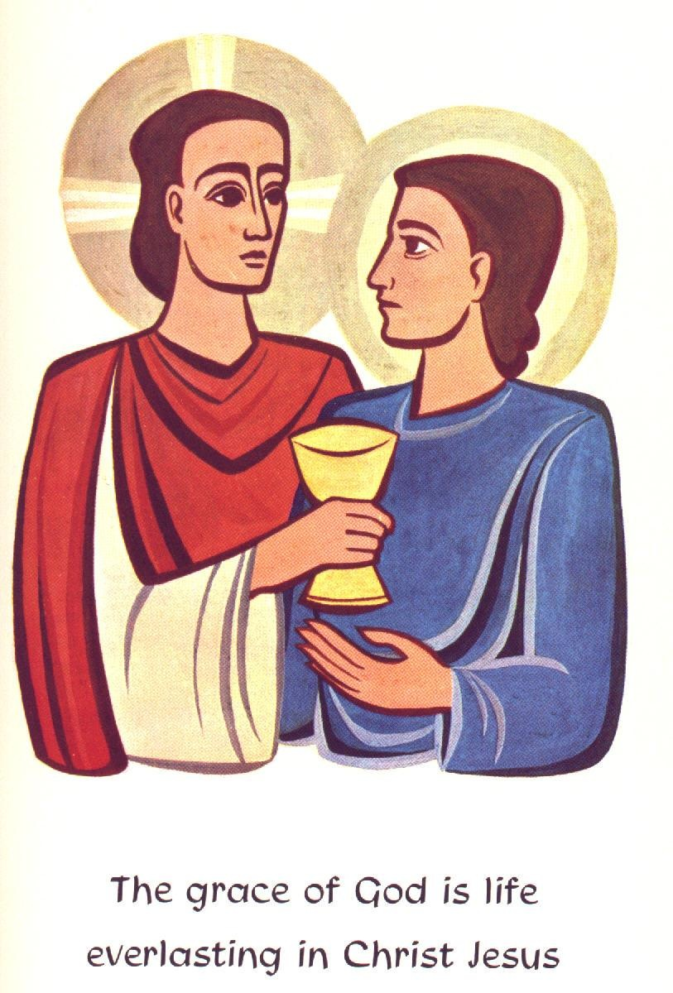
The Our Father, the prayer that Jesus taught His disciples to pray, is the “table prayer” with which we come to the Lord’s Table (Matthew 6:9-13; Luke 11:2-4; Conclusion: Galatians 1:5; Hebrews 13:21; Revelation 1:6).

The Words of Institution
The pastor speaks the Lord’s own word; these words give and bestow what they declare, the Body and Blood of Christ. “Christ Himself prepares this table and blesses it. No human being, but only Christ Himself who was crucified for us, can make of the bread and wine set before us the Body and Blood of Christ. The words are spoken by the mouth of the priest, but by God's power and grace through the words that He speaks, `This is my Body,’ the elements set before us in the Supper are blessed. Just as the words `Be fruitful and multiply and fill the earth,’ were spoken only once but are ever efficacious in nature and make things grow and multiply, so this word was indeed spoken only once, but it is efficacious until this day, and until His return it brings it about that His true Body and Blood are present in the church’s Supper” (St. John Chrysostom on the Significance of the Words of Institution, quoted in The Formula of Concord, SD VII,76).

Pax Domini
Showing them His wounds, the Risen Lord declared His peace to His disciples on Easter Evening. That same peace is given with the Lord’s Body and Blood (1 Corinthians 11:23-26; Matthew 26:26; Luke 22:19; John 14:27, 20:21).

Agnus Dei
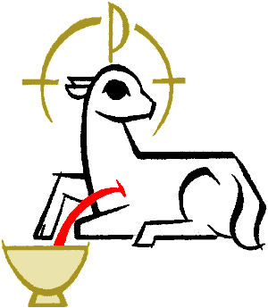
Agnus Dei is a Latin phrase meaning “Lamb of God.” For centuries the blood of lambs sacrificed on Israelite altars pointed forward to the one great sacrifice of the “Lamb of God who takes away the sin of the world.” As John the Baptist greeted our Lord with this title (John 1:29), he was identifying Jesus as the long awaited Messiah. The threefold repetition the Agnus Dei emphasizes Christ's vicarious atonement. His Body and Blood, given and shed for His people, takes away our sin and delivers us from death. As we approach His Holy Table, we acknowledge that Christ, “our Passover Lamb” (1 Corinthians 5:7), has been sacrificed for us.

Distribution
We come to the Lord’s Table hungry and thirsty and He feeds us with His Body and refreshes us with His blood; this is the Lord’s Supper. As Luther reminds us, “Our Lord is at one and the same time chef, cook, butler, host and food” (John 1:29; Isaiah 53:7; Ephesians 2:13-17; 1 Peter 1:19-20; Revelation – more than 30 references including 5:6,12, 14:4, 15:3, 17:14, 19:9, 21:23).

Nunc Dimittis
Nunc Dimittis means “Now You let depart.” Having received the Lord’s Body and Blood for our salvation, like Simeon who held in his arms the Savior of the world, we go in peace and joy singing Simeon’s song (Luke 2:29-32).

Prayer of Thanksgiving
Before we leave the Lord’s Table, we give thanks, asking that the salutary gift of Jesus’ Body and Blood would have its way in our lives, strengthening us in faith towards God and fervent love toward one another. The Sacrament draws us outside of ourselves to live in Christ by faith and in the neighbor by love (Luke 2:29-32; 1 Chronicles 16:1-10; Psalm 107:1, 118:1).

Benedicamus & Benediction
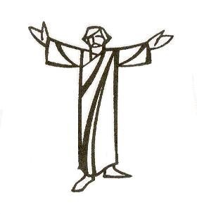
Having received His gifts the Church cannot but praise her Lord; Benedicamus means “Bless we the Lord!” The Lord begins and closes the Divine Service; His Name upon His people by Holy Baptism (recalled through the Invocation) and Benediction, encompasses the whole service. We are now marked with the Lord’s Name in the Benediction—that word of God’s blessing from Numbers 6 in which He favors us with His grace and peace. With the Lord’s Name given us in Holy Baptism we were drawn together. Now with that same Name, He sends us back into the world, to the places of our various callings to live by the mercy we have received as living sacrifices to the praise of His glory and the good of our neighbor I Corinthians 15:57; Psalm 41:13, 72:19, 89:52, 106:48, 150:6; Numbers 6:22-27; Romans 12:1-2).

Glossary
Absolution: the forgiveness of sins from God Himself through the word of His called ministers. The actual word of Jesus spoken to a penitent sinner: “Your sins are forgiven” (Matthew 9:2). Through the hearing of this word, the confessing Christian is justified by God and receives the forgiveness of sins for Jesus’ sake.
Alb: a long white linen vestment properly worn at the celebration of Holy Communion
Altar: the most important article of church furnishing and the focal point of divine worship.
Amen: the word of faith that declares, “I believe that word which was prayed, preached, or spoken. Let it be done as God has promised.”
Catechism, Small: a brief book explaining the chief articles of the Christian faith; written by Dr. Martin Luther.
Catholic: this word means the one faith confessed in all times and in all places. It is used to describe the one, holy, apostolic, and also the true Christian faith. Unfortunately, it has become a synonym for the Roman Catholic Church.
Chalice: the liturgical cup used in the Holy Communion service.
Chancel: the east end of a church, above and beyond the nave and beyond the chancel rail.
Christ (Messiah): the title given to Jesus that means “Anointed One” and the fulfiller of the entire Old Testament. This title encompasses every designation for the promised Savior.
Christ, Humiliation of: the Son of God kept His divine majesty hidden and, as an obedient servant, submitted Himself to every human limitation in a fallen world.
Christ, the Two Natures of: the Son of God, since His incarnation, is true God and true man one Person.
Church, the Holy Christian Church: the assembly of all believers [in Christ] among whom the Gospel is preached in its purity and the holy sacraments are administered according to the Gospel.
Ciborium: a vessel used for storing or in distributing Holy Communion wafers.
Crucifix: a cross with a carved figure of the crucified Jesus emphasizing that Christ became man to be mankind’s Redeemer and Lord.
Daily bread: the gifts that God provides to sustain us each day in life and faith, including food for the body and spirit.
Descent into hell: the first event in Christ’s glorification, when He descended bodily to preach His victory over Satan and all his hellish powers.
Divine Call: the call from God through the Church to a man, to be a public minister of the Gospel, that is, the authority to preach and teach the Word of God and administer the sacraments in the stead of Christ.
Epistle side: the right, or south, side as you face the altar.
Faith: the trust of the heart. Belief in Christ for the forgiveness of sin, life, salvation, and all that we need. Reliance or dependence on God. That which receives and clings to God’s gifts of mercy and grace.
Flagon: a covered vessel into which wine is poured for use in the Holy Communion service.
Forgiveness of sins: God for Christ’s sake no longer holds my sins against me.
Gospel: the saving message of God’s grace and forgiveness to sinners in the death and resurrection of Jesus Christ.
Gospel side: the left, or north, side as you face the altar.
Grace: the “fatherly, divine goodness and mercy” of God. His undeserved favor and love. It moved Him to create us out of nothing and to save us while we were still sinners, and it still moves Him today to provide us with daily bread and to give us the gifts of salvation for Jesus’ sake.
Incarnation: the Son of God took on human flesh and became man in His conception, so that there is a union of the divine person of the Son of God with the human nature.
Jesus: the proper name given to the Son of God at His conception and birth that means “the Lord (Yahweh) saves”.
Keys: the power to “open the door” of Heaven and restore communion with God through the word of forgiveness, or to “close the door” of Heaven by withholding forgiveness from the impenitent. The authority of the Holy Ministry. This authority is given to the Church by Christ Himself and is exercised in His stead by her ministers.
Kingdom of God: The reign of Christ, through the Spirit, in the hearts and lives of His people.
Lectern: a stand at which the readings are read in the service.
Life everlasting: the immortal, incorruptible, eternal life with Christ in which there will be no more sin, curse, sorrow, suffering or death.
Liturgy: the Church’s worship of God.
Love: to desire the Lord your God with all your heart, soul, mind, and strength.
Means of Grace: the “vehicles” or “channels” through which the Holy Spirit gives Christ to us with all His gifts of grace.
Mercy: the kindness and grace of God that does not hold our sins against us but freely forgives us for Christ’s sake.
Narthex: the entrance hall, providing space for transition from the outside world to the church proper.
Nave: the main body of a church, extending from narthex / entrance to the chancel.
Neighbor: anyone in need whom God has “placed in your path,” whether he is a friend or an enemy, a believer or an unbeliever.
Octave: the first and following seven days after the celebration of a feast.
Officiant: the conductor or leader of a minor service.
Ordinary: the invariable parts of the liturgy.
Ordination: the “holy orders” and “solemn charge” given to the man being placed into the Office of the Holy Ministry to tend, keep, and defend the Holy Gospel of Christ and His congregation, through the faithful preaching and teaching of the Word of God, judging doctrine, remitting and retaining sin, and administering the sacraments of Christ according to His institution.
Paten: a plate for the distribution of the wafers in the Holy Communion service.
Penitent / repentant sinner: a sinner who is sorry for his sins (contrite), confesses his sins, and believes that only Christ can forgive him, not on account of his own confession or sorrow, but because God is merciful for Jesus’ sake.
Priesthood: the word that describes the baptized people of God as those who live as “priests” for one another in the various vocations to which God has called them, they listen to the Word of God, they pray, they confess, they teach, and they offer the sacrifices of love to their neighbors and a “broken and contrite heart” to God.
Propers: the variable parts of the liturgy.
Pulpit: the place from which the Word of God is preached.
Real Presence: the true body and blood of Christ are present and distributed to every communicant in the Lord’s Supper, along with the bread and the wine, because of the word and promise of Christ.
Repentance: the knowledge of your sin and corruption, to be turned away from your sins, through the preaching of the law and gospel, to faith in Christ’s word of forgiveness.
Resurrection of the Body: the bodies of all the dead will rise on the Last Day and be reunited with their souls-unbelievers to condemnation and torment of hell and beliers to incorruption and immortality with Christ.
Right Hand of God: Jesus’ position of authority from the Father to reign over all things for the sake of His Church.
Rubrics: directions for the conduct of a service.
Sabbath: the name of the seventh day of creation that literally means “day of rest.” For the Christian, this word refers to the “rest” and “peace” which God now gives, for Christ’s sake, through the hearing of His Word and the receiving of His sacraments.
Sanctification: all that the Holy Spirit does through the Word and Sacraments of Christ to make us holy. It is the entire work of the Holy Spirit in the life of a Christian through which he is brought to faith in Christ through the forgiveness of sins, the “old man” is put to death, and the fruit of the faith are brought forth in his life.
Sanctuary: the part of the church where the altar is located.
Sacristy: a special room in which vestments and other furnishings and items for the service at the altar are kept.
Sin: rebellion against God; turning away from His Word; unbelief; every thought, word, and deed, which is against the will of God.
Trinity, the Holy: the Father, Son, and Holy Spirit who is the one true and living God. Love is His nature, which He extends to mankind in His works of creation, salvation, and sanctification.
Virgin Birth: the Son of God was both conceived by the Holy Spirit and born of Mary’s flesh without the aid of man, in order that He might be like us in every way, except without sin.
Vocation / calling: the position in life that God has placed you, such as husband, wife, father, mother, son, daughter, employer, employee. It includes your life’s work and the responsibilities you have been given by God toward others.
Worthy Reception: receiving the Lord’s body and blood as a penitent sinner with faith in His words, “This is My body, which is given for you…This cup is the new testament in My blood, which is shed for you for the forgiveness of sins.” Such reception presupposes Baptism and catechesis.

Nave
Narthex
Sacristy
Pulpit
Chancel
Altar

